**SAP BW/BO Exercise**

**Exercise 8: Extract, Transformation, & Load**

**Student Name: Nupur Ray Student Id: nxr163130**

**Date: 14/09/2016**

**Note: You must use the following conventions to name objects/systems created in this exercise.**

**Replace SM with A - for Fall semester**

**B - for Spring semester**

**C - for Summer semester**

**Replace YY with the last 2 digits of the current year.**

**Replace XXX with your SAP ID.**

**Objective**

The exercise is designed to help the student acquire the ability to

* Use the Source system created in the previous exercise
* Use the Application Component created in the previous exercise
* Create a Data Source
* Create Transformation
* Create Info Package
* Create Data Transfer
* Load Text Data
* Create Transformation to Cube
* Create and start Data Transfer Process to Cube

**Master Data**

Master Data are used to validate when we load the transaction data. When we say we are loading master data we are actually loading Attribute and Text data. Loading master data involves creating/using

1. Source System
2. DataSource
3. Transformation
4. InfoPackage
5. Data Package

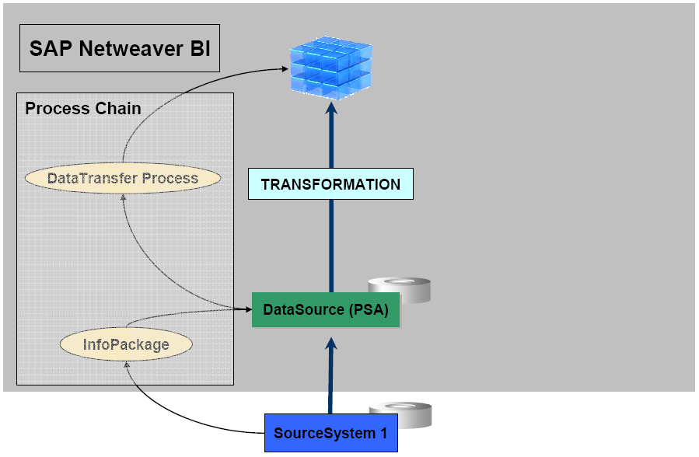

1. **Create a Data Source**

To distribute information about attributes and texts to the respective tables of your cost center characteristic, create a DataSource for flat file upload and extract the CSV file by using the flat file interface.

**Note**: We do not add Master Data for display attribute. They are added along with Characteristic with which they are associated.

1-1: Right-click the created Application Component previously(under DataSource in Modelling), and then select Create DataSource….

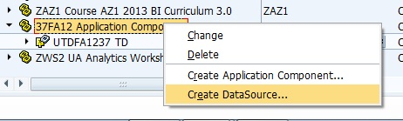

1-2: Select the option for Data type DataSource: Master Data Attribute and enter the DataSource Name: **CustAttributeDataSource_SMYYXXX** . Then click continue.

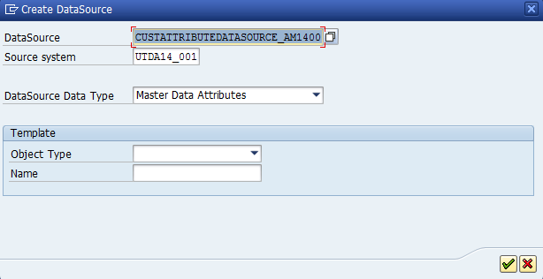

1-3: In the General Tab Enter the Short Description: Customer Attribute

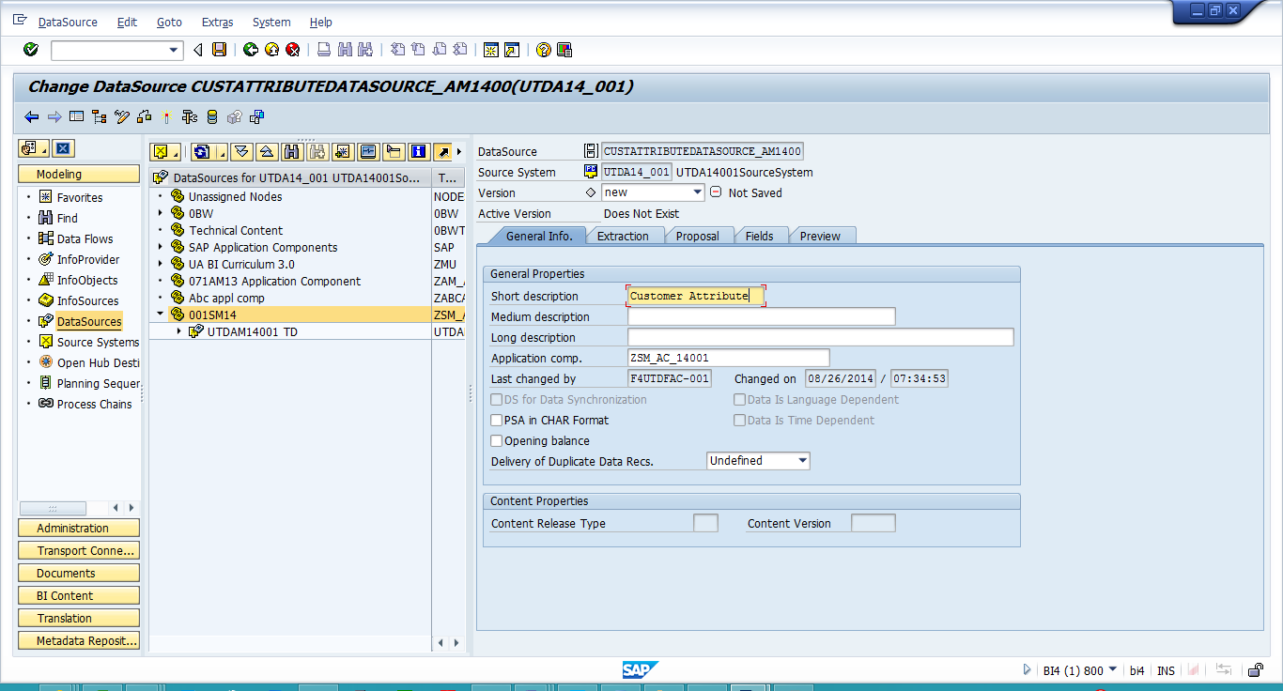

1-4: In the Fields Tab, Enter under Template infoObject: CIDSYYXXX and then click on the icon to add new line.

1-5 If a Pop Windows come asking to copy fields of the template say **COPY**.

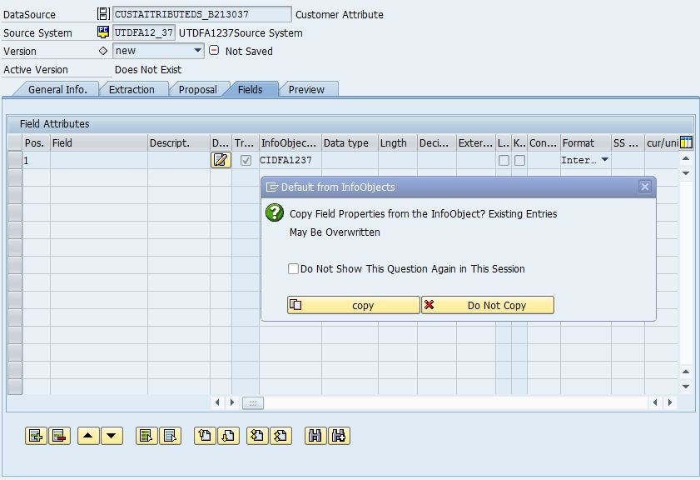

1-6: Now in the 2nd row under template type in: CNMSYYXXX and then click on the icon  to add new line.

1-7: If a Pop Windows come asking to copy fields of the template say COPY.

1-8: Now in the 3rd row under template info object type in: CADSYYXXX. Click on the icon  to add new line. If a Pop Windows come asking to copy fields of the template say COPY.

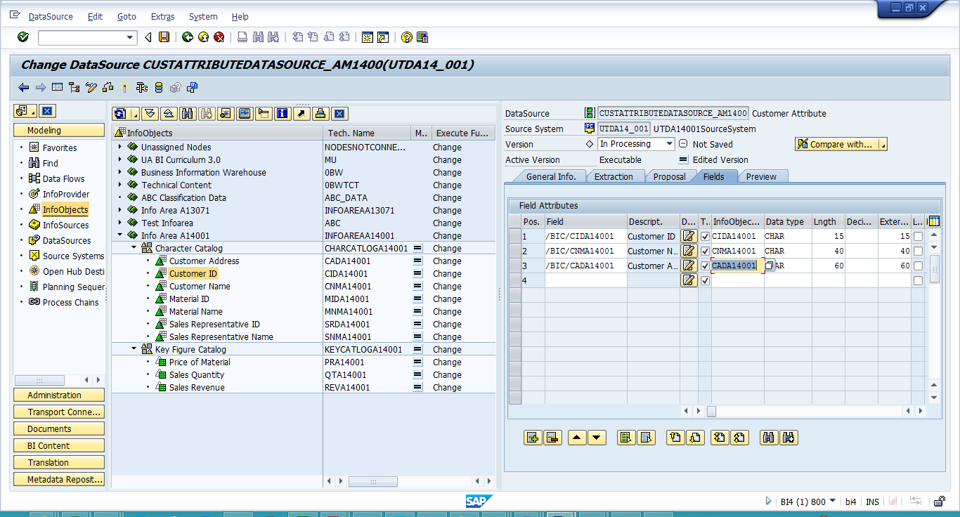

1-9: Delete the 4th empty row created by clicking Add row icon  , By selecting the row as a whole (click on the grey button to the left of pos.4) and select delete row button C:\Users\Karthikeya\Desktop\Work\BI5 Assignment Migration\Assignment 8\5.JPG.

1-10: Look at the Fields tab content. If Data Type field and Lngth are not automatically filled choose “**CHAR**” for the three characteristics for “Data type” and enter the length of the characteristics in “**Lngth**” as shown in the screen shot below.

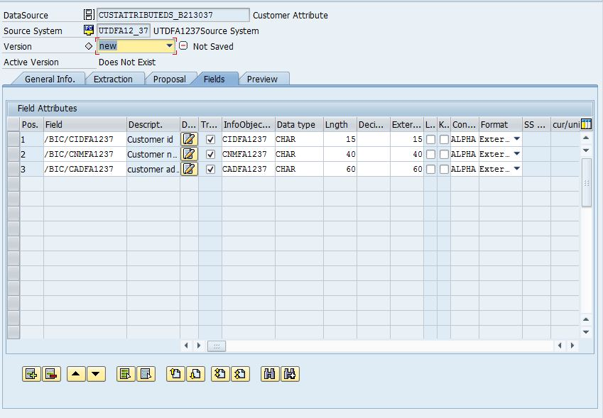

1-11: Make sure your screen in the fields tab looks exactly the same and Now check & activate the component by clicking on the “check” Icon, if check is successful stay on the fields tab and click on “Activate” icon.

**1-12: Paste the screen shot of Status Message of activation, make sure fields tab is visible:**

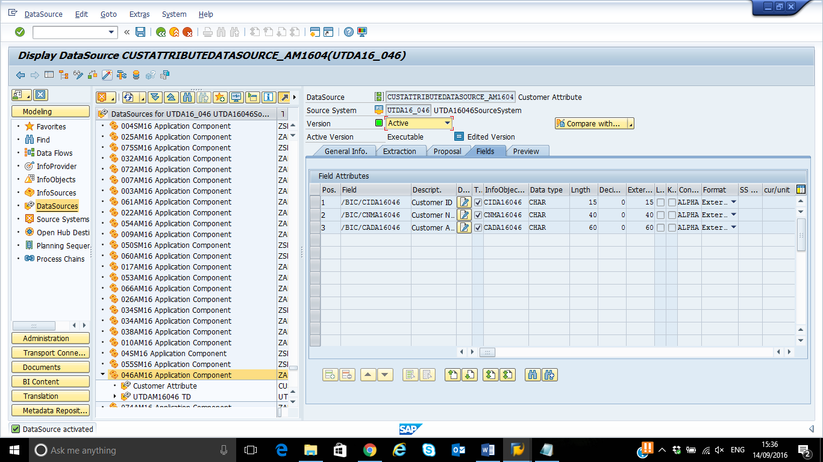

1-13: Navigate to the extraction tab and Select “In processing” for the version field and do the following Changes:

Step 1: *Data Format: Separated with Separator (for Example, CSV)*

Step 2: *Data Separator: ‘ , ‘*

Step 3: *Adapter: Load Text Type File from Local Work Station*

Step 4: *Name of the File: Select the location where the csv file is stored. (For Customer: CustomerAttribute.csv)*

Step 5: *Header rows to be ignored: 1*

Step 6*:* Select “Allowed” for Direct Access. This means that the data are not loaded from the PSA but from the DataSource. Your screen should look like the one below.

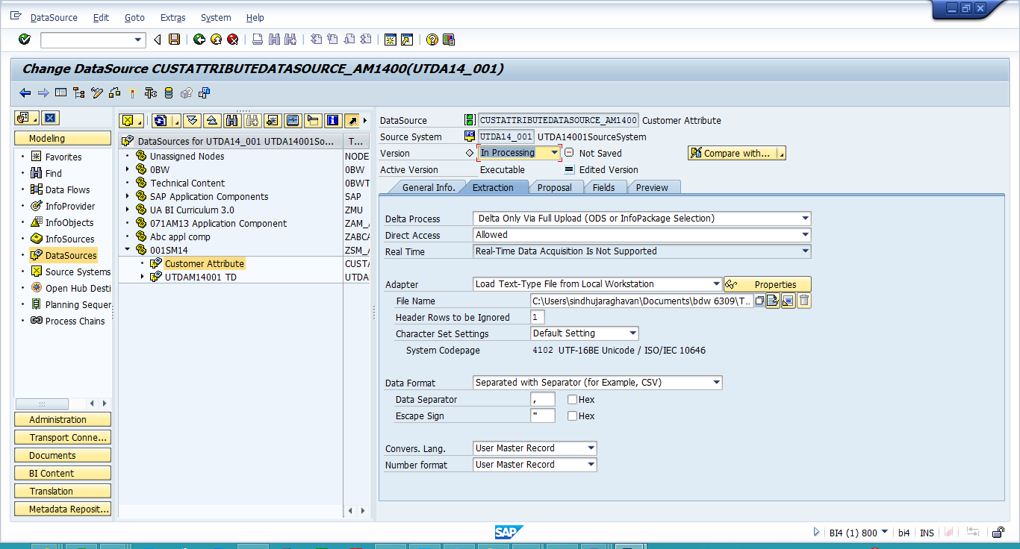

1-14: In the Proposal Tab, click on Load Example Data to check if the format is correct. (If you get any SAP security pop-up make sure that you should always select “Always allow” and then move ahead)

**1-15: Paste the Screenshot here**

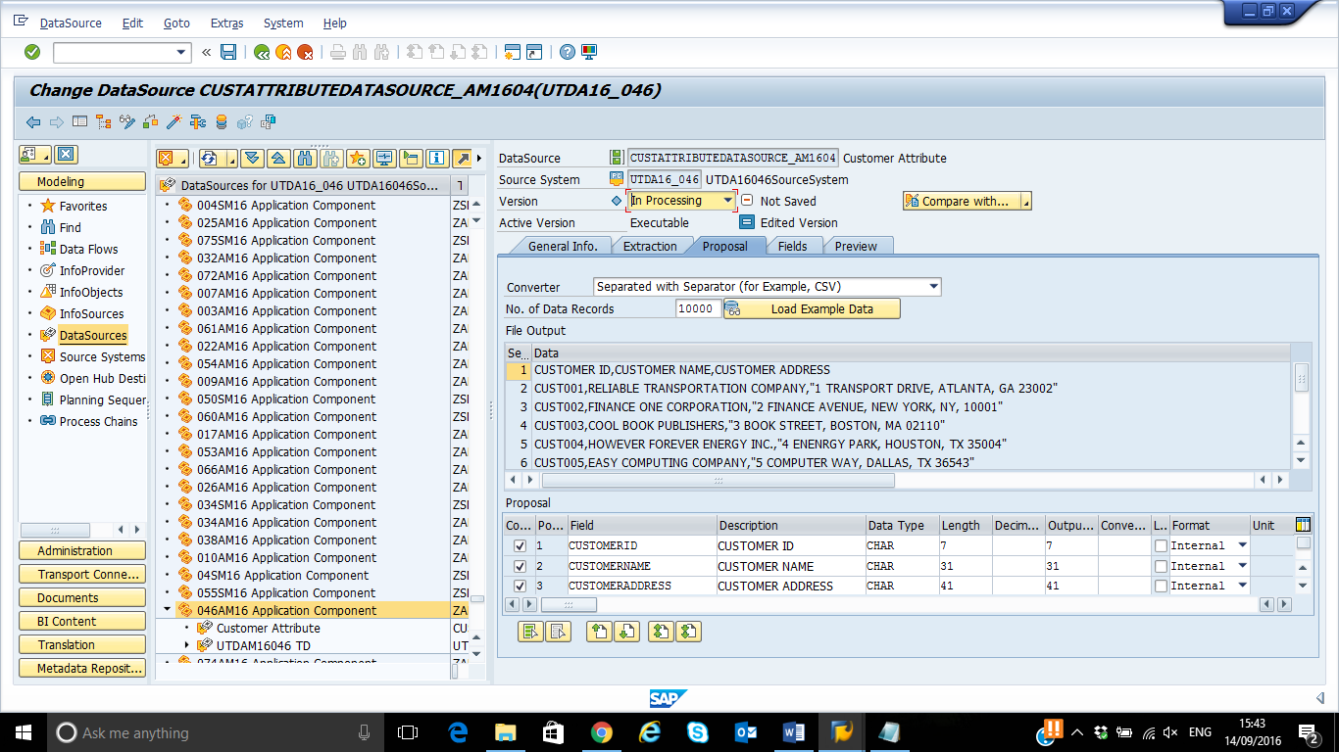

1-16: Now **Check & Activate** the DataSource. A window “ Copy changes” Pops up, always click **NO.**

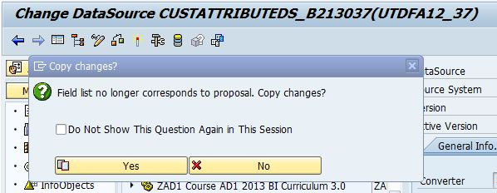

Check Button

Activate Button

1-17: Click on **Preview** Tab now. Click on Read Preview Data.

**1-18: Paste the screenshot here**

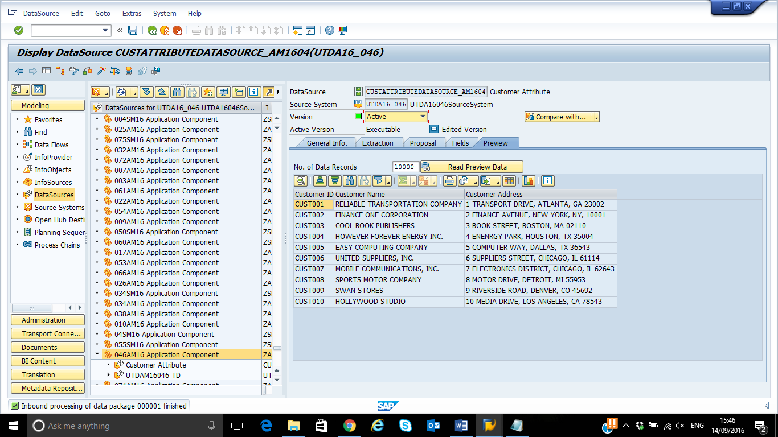

1. **Create Transformation**

Connect your DataSource with the attributes and text tables of your characteristics InfoObject. To do this, create transformations between the two objects. You need to create one set of transformations for uploading the text data to the text table, and another one for filling the attribute data.

2-1: Right click on the new data source created in the center panel and select Create Transformation.

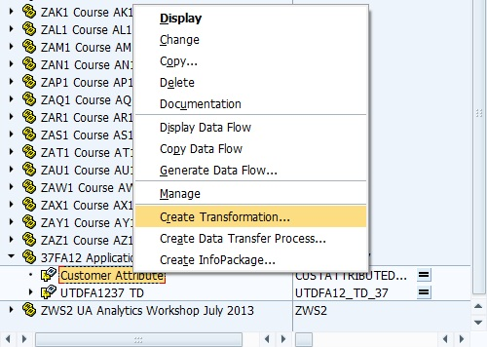

2-2: In the Create Transformation window enter the following details:

Target of the Transformation:

Step 1: Object Type: Info Object

Step 2: Subtype of Object: Attribute

Step 3: Name: CIDSYYXXX

2-3: Click Continue.

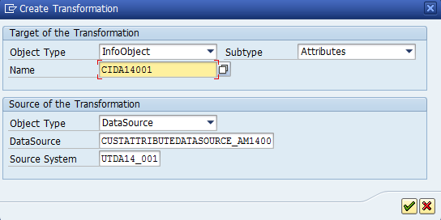

Note: If you get a pop up that says the "InfoObject is not assigned to InfoArea", close the pop-up and do the following steps:

Type RSA1 in the Commandline.

Click on InfoObjects under Modeling. Locate your InfoArea.

Expand the Character catalog under your InfoArea.

Right click on the InfoObject(say CustomerAddress)->Select Change from the context menu

Click on the "Master data/texts" tab and enter the name of your InfoArea

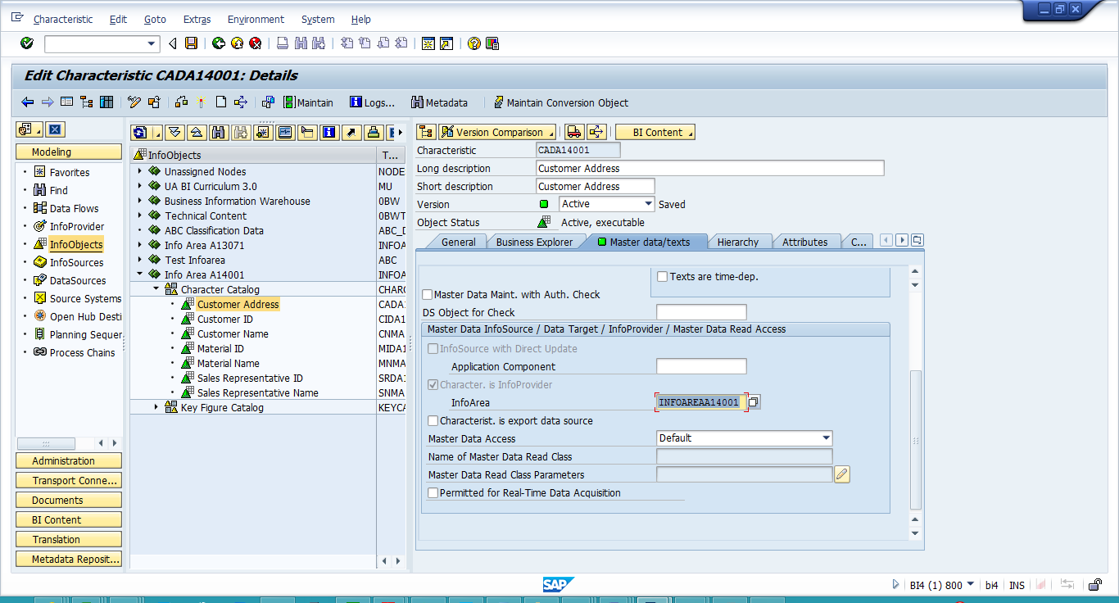

Save, check and activate the InfoObject.

Repeat the same procedure for all the InfoObjects under the Character Catalog.

Now, Continue with the "Create Transformation" process.

2-4: In the next screen the connections are automatically generated with a message along with letting us know about the number of transformation rules that have been created for the transformation.

(Note if the connections are not generated automatically please make the connections as shown below)

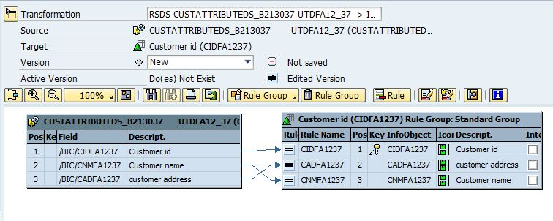

**2-5: Write the Status Message - How many proposals were generated ? :-**

**Proposal generated with 3 rule(s)**

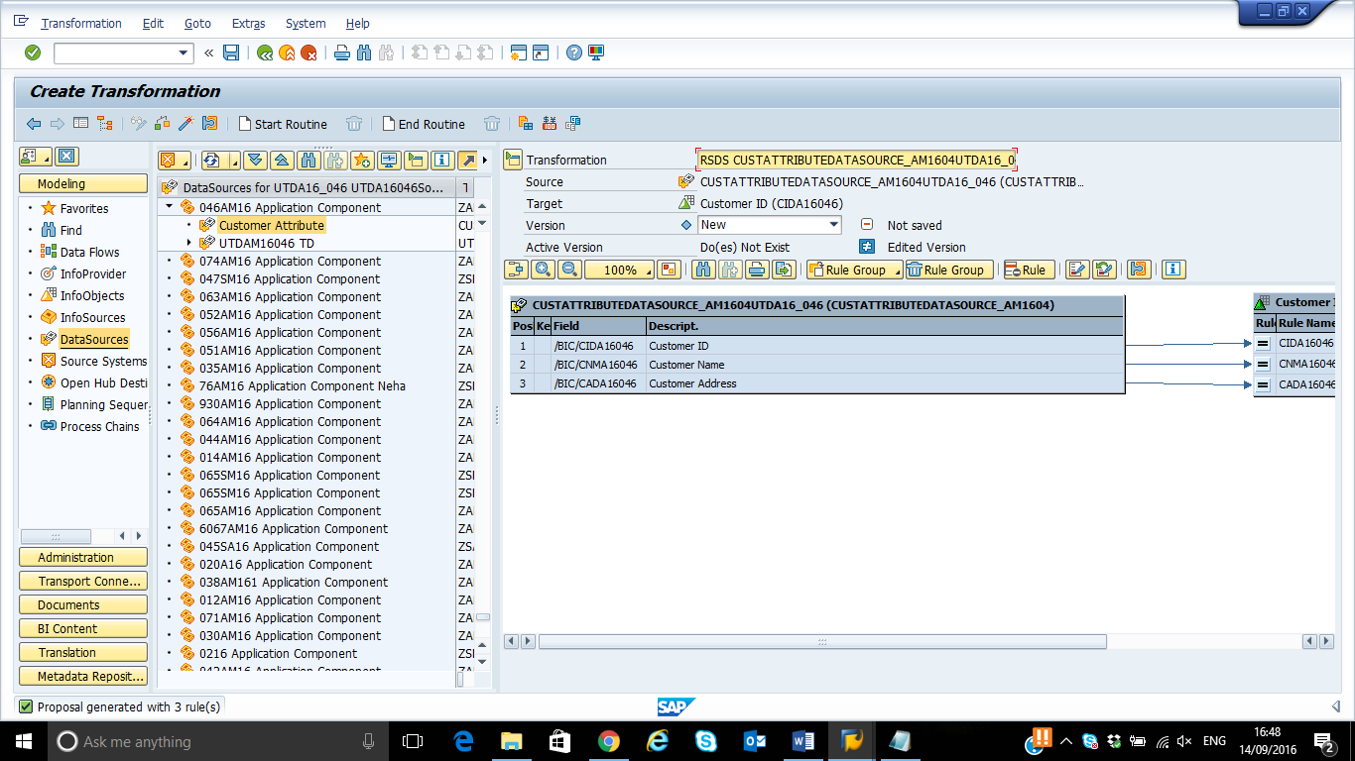

2-6: Check & Activate the Transformation. Ensure that you have connected all of your Infoobjects with arrows from left to right as shown in the screen above.

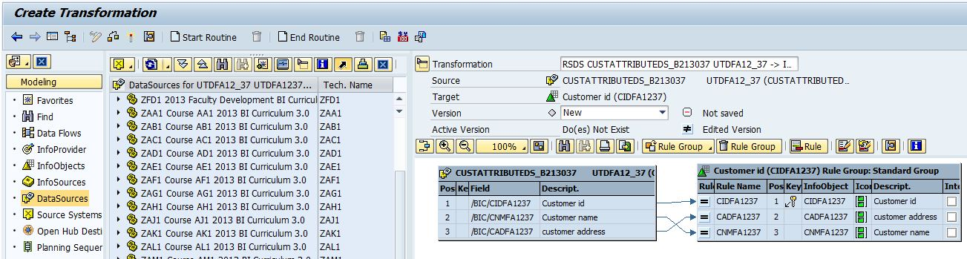

Activate Button

**2-7: Write the status message – After Activation:**

**Transformation activated successfully.**

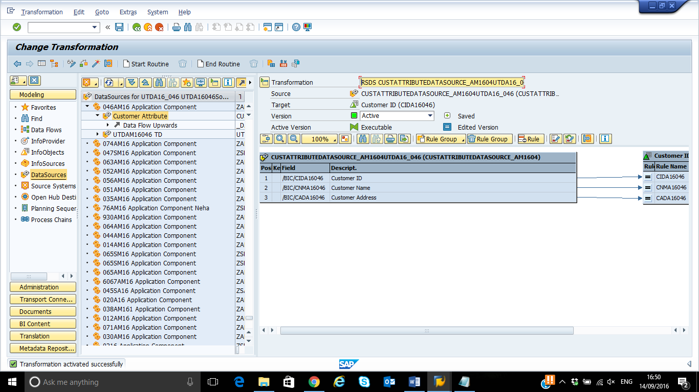

**3)Create Info Package**

After you have defined the data flow, load the data from your flat file to the corresponding PSA table.

3-1: Right-click the Datasource Customer Attribute, and then select Create InfoPackage….

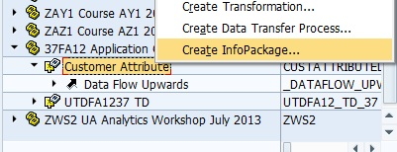

3-2: Select the DataSource Customer Attribute Data, enter Infopackage description: “InfoPackage CustomerId Attribute “,and then save to continue. 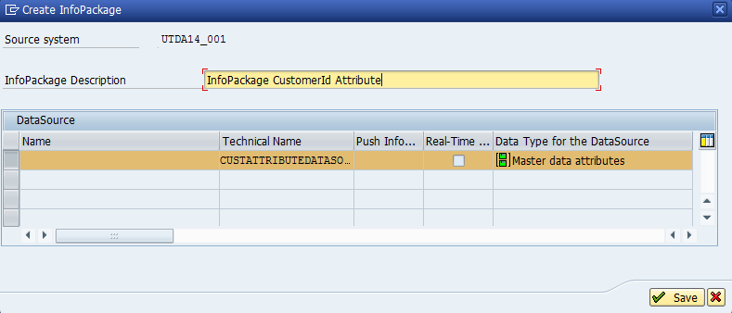

3-3: In Extraction tab, select options as shown in the screen.

Step 1: File type: CSV file

Step 2: Data separator ‘ , ‘

Step 3: Number of Header Rows to be Ignored: ‘1’.

Step 4: File name is populated automatically.

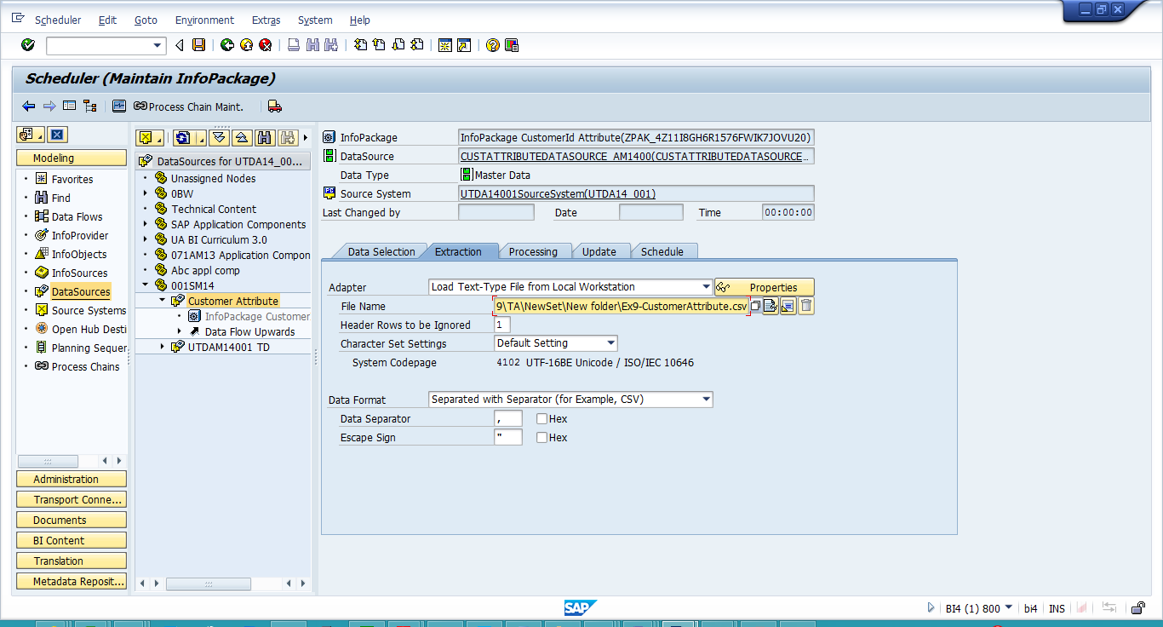

3-4: Click the Schedule tab, select the option Start data load immediately, and then click start to load data. ( Note : choose Allow if a pop up box appears to ask for the access permission)

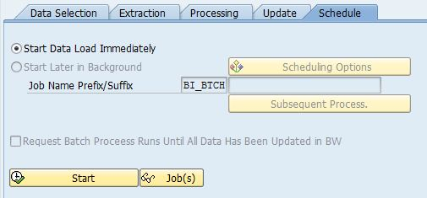

3-5: On top there is a monitor button  to check the status of the load. Check the status it should be green if successful. (To get the screen like the one below click on the Green square the details of the load will be displayed)

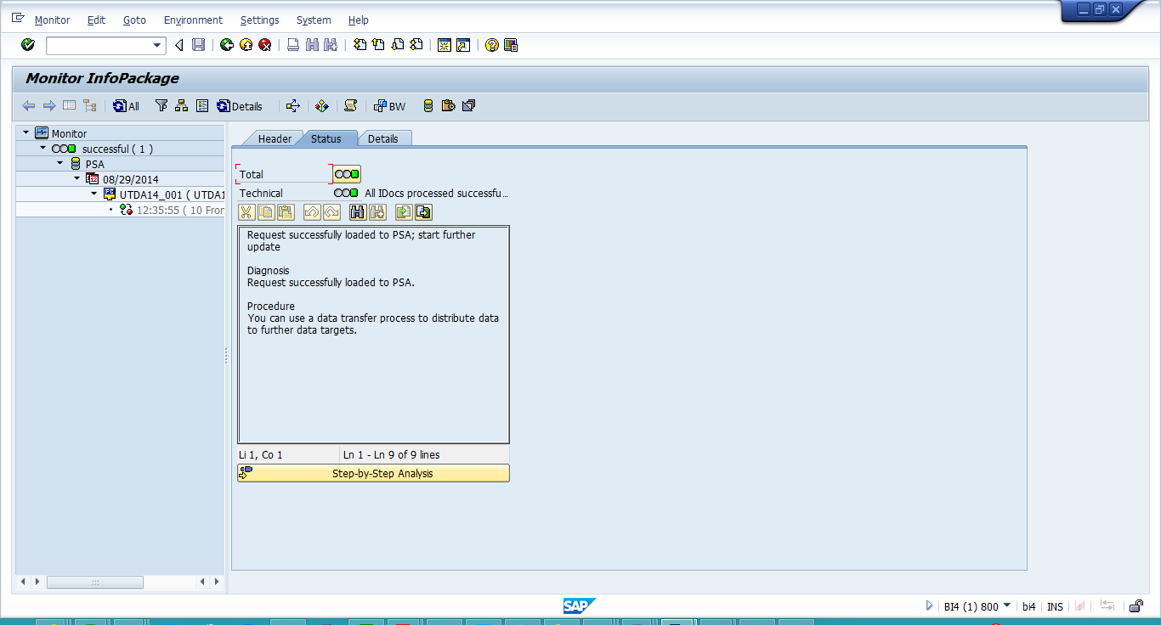

**Answer the questions**

**3-6: Paste here the Monitor Screenshot for Attribute Data load.**

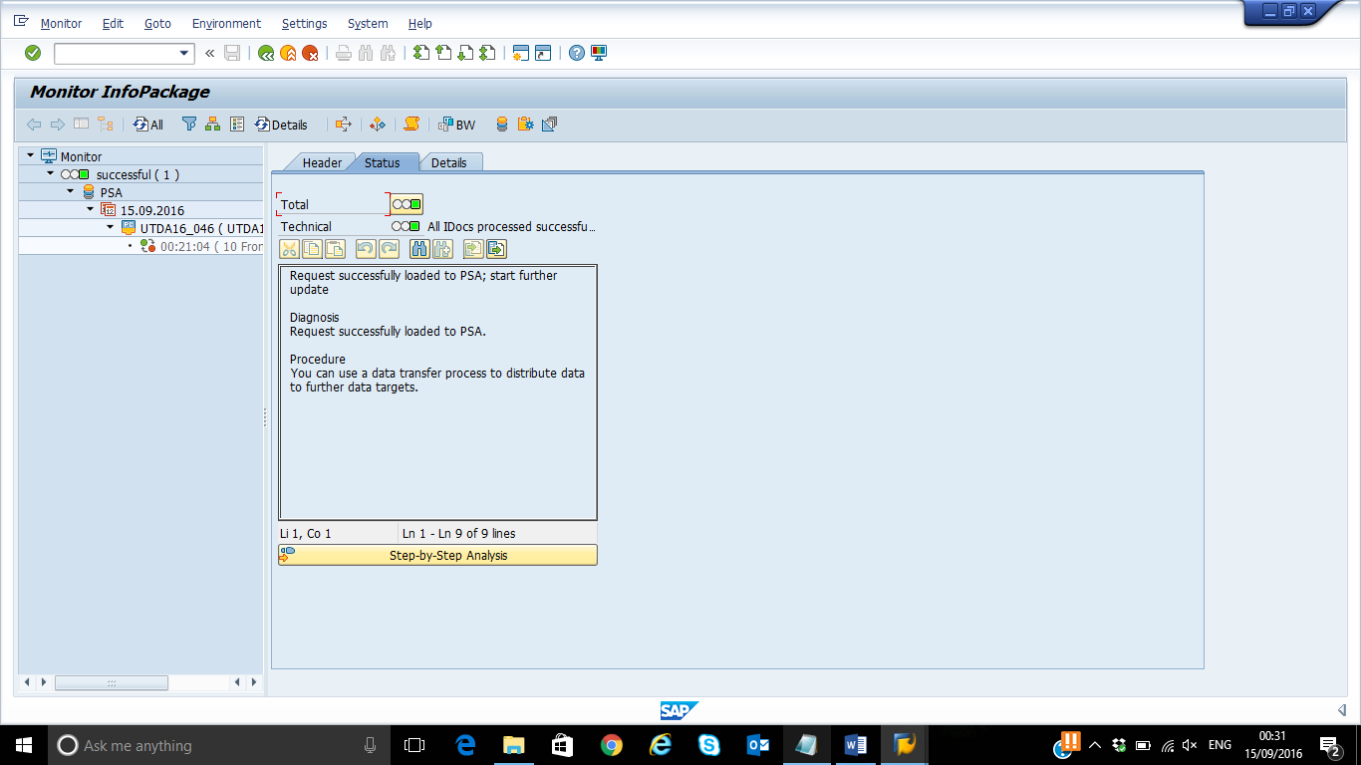

1. **Creating Data Transfer Process**

Create and schedule data transfer processes, one for the attribute and one for the text data, to load the master data from the PSA table to the master data tables of your characteristics InfoObject.

4-1: Right click the Datasource and select Create Data Transfer process.

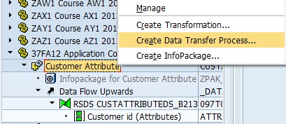

4-2: Click continue. In the Pop up window, enter/ ensure details according to the following screenshot.

Name : CIDSYYXXX

Object Type: InfoObject

Subtype of Object : Attributes

The Data Transfer Proc. Field will get auto-populated.

(Note: If it is not populated automatically, try to logoff and login again).

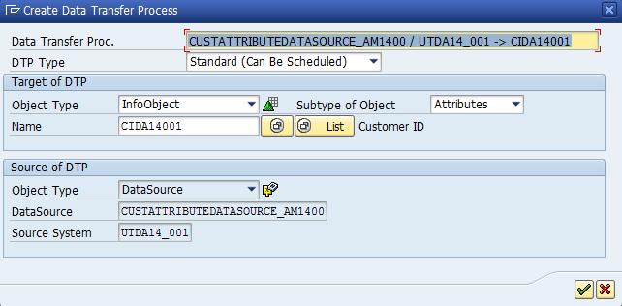

Click Enter.

4-3: Extraction Tab:

Step 1: Extraction Mode: Full

Step 2: In the Update Tab - Error Handling: Valid Records Update, No Reporting (Request Red)

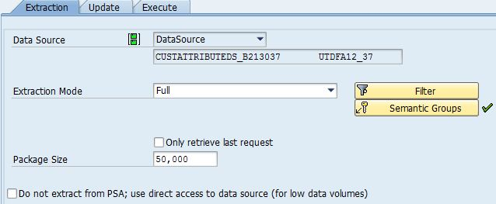

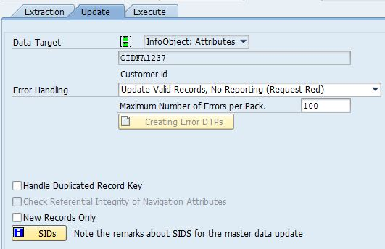

4-4: Activate the Data Transfer process

4-5: Execute Tab: Click Execute Button

4-6: Pop up window say YES.

**Answer the questions**

**4-7: Paste a Screenshot of Data Transfer Process Monitor.**

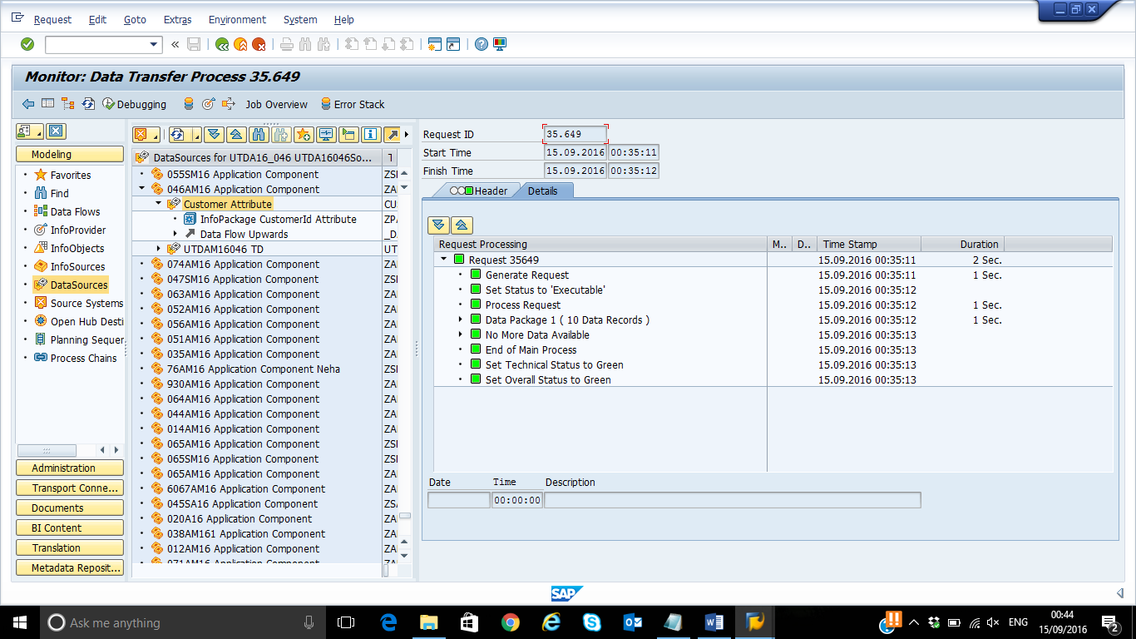

1. **Navigate to your Customer ID characteristic (Info Objects section) and maintain the master data in order to check the data load.**

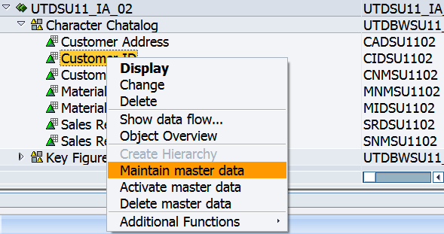

**Click on “Execute” icon.**

**Loaded data appear on the screen:**

**Paste your screen shot here:**

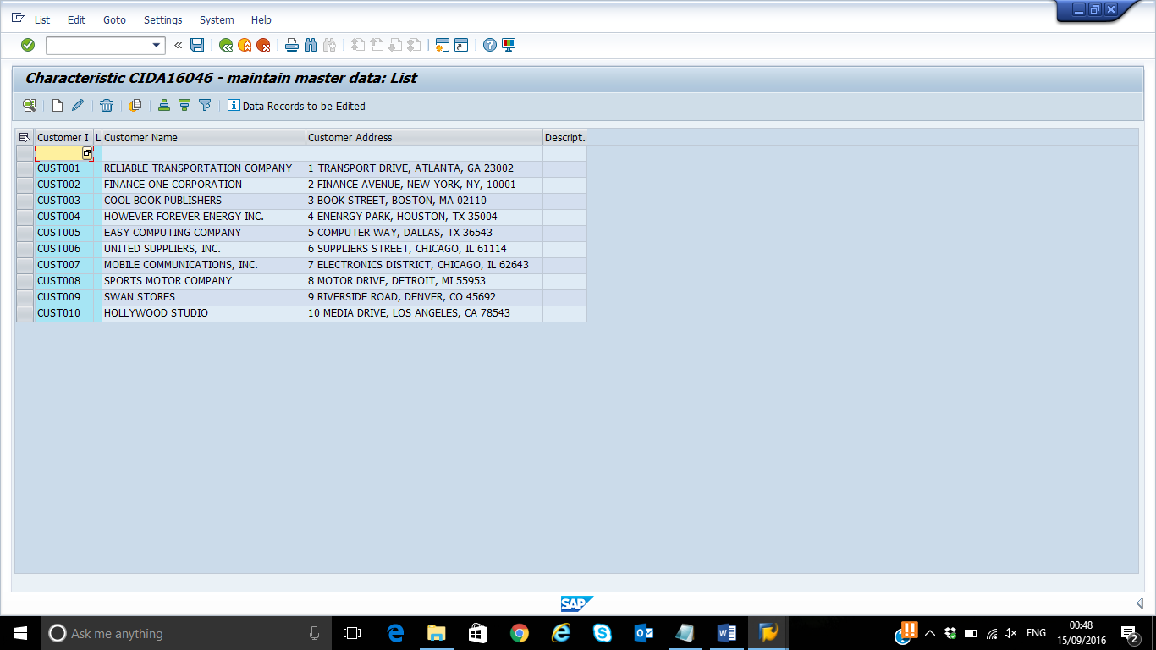

1. **Load Text Data**

5-1: Right-click the previously created Application Component, and then select Create DataSource.

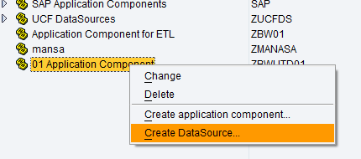

5-2: Select the option for Data type DataSource: Master Data Text and enter the DataSource Name: **CustomerTextDataSource_XXX**. Then click continue.

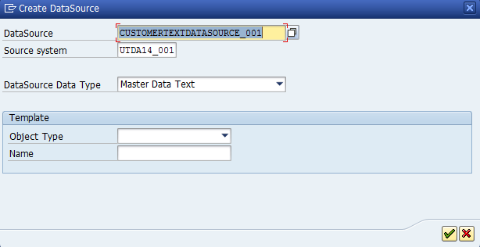

5-3: Click Continue

5-4: In the General Tab Enter Short Description: Customer Text

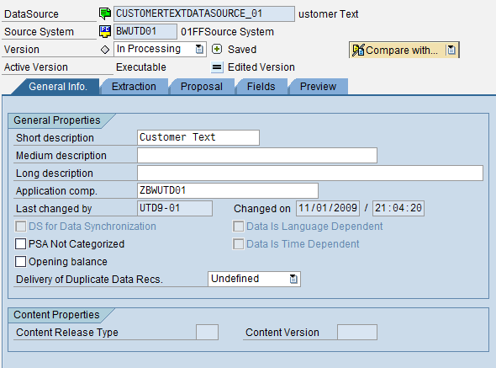

5-5: In the Fields Data, Enter under Template infoObject: 0LANGU and then click on the icon  to add new line.

5-6: If a Pop Windows come asking to copy fields of the template say COPY.

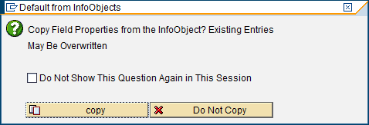

5-7: Change the Field Length of Lang to 2 and add in “Data type” field “LANG”.

5-8: Now in the 2nd row under template type: CIDSYYXXX and then click on the icon  to add new line.

5-9: If a Pop Windows come asking to copy fields of the template say COPY.

5-10: Now in the 3rd row under template info object type in: 0TXTSH and then click on the Extraction Tab.

5-11: If a Pop Windows come asking to copy fields of the template say COPY.

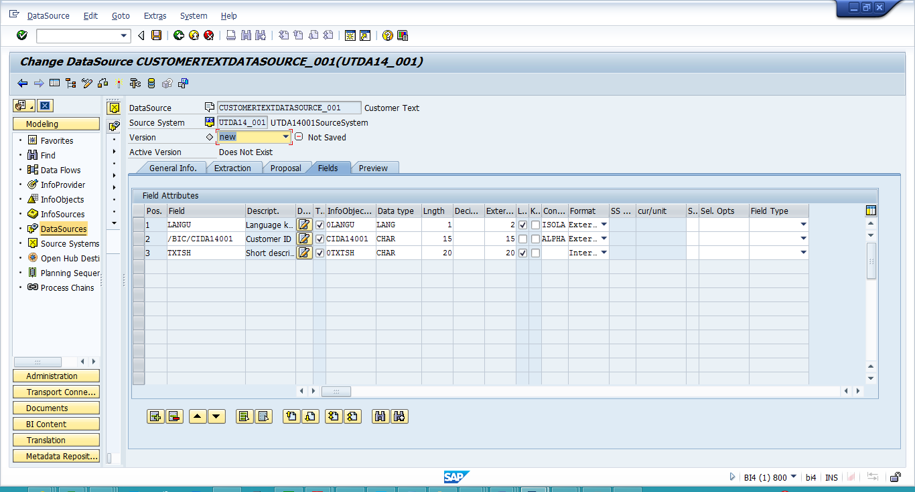

5-12: In the extraction tab do the following Changes:

Step 1: Data Format: Separated with Separator (for Example, CSV)

Step 2: Data Separator: ‘ , ‘

Step 3: Adapter: Load Text Type File from Local Work Station

Step 4: Name of the File: Select the location where the csv file is stored.(For Customer: CustomerText.csv)

Step 5: Header rows to be ignored: 1

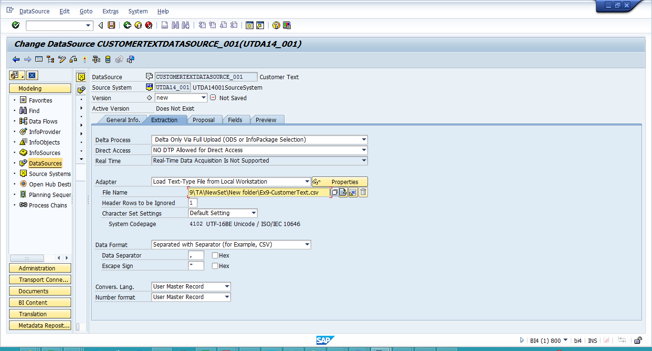

5-13: In the Proposal Tab click on Load Example Data to check if the format is correct. After clicking the button you should get the below Screen shot. (If you get SAP GUI security pop-up, always select “Always allow”)

**5-14: Paste your screenshot here**

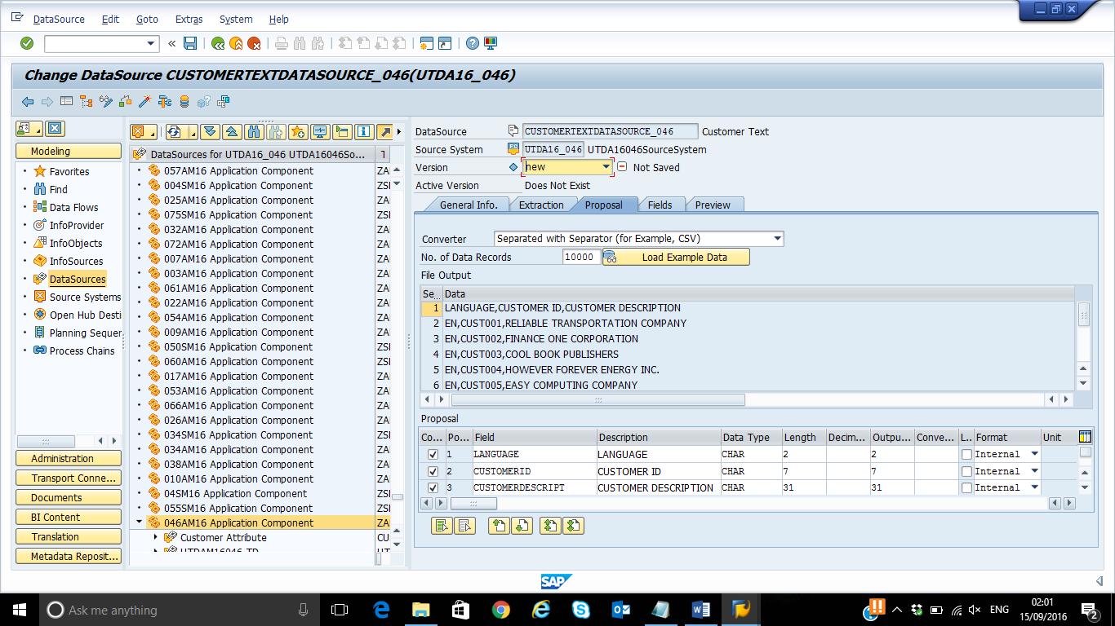

5-15: Now Activate the DataSource. A window Pops up say NO

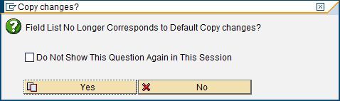

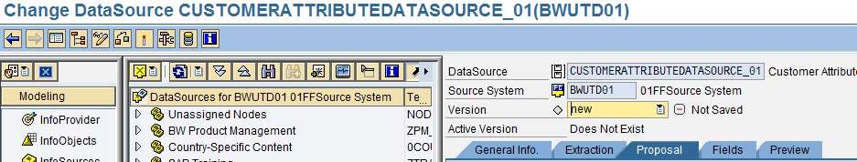

Activate Button

5-16: Click on Preview Tab now. Click on Read Preview Data.

**Answer the questions**

**5-17: Paste your screen shot here-**

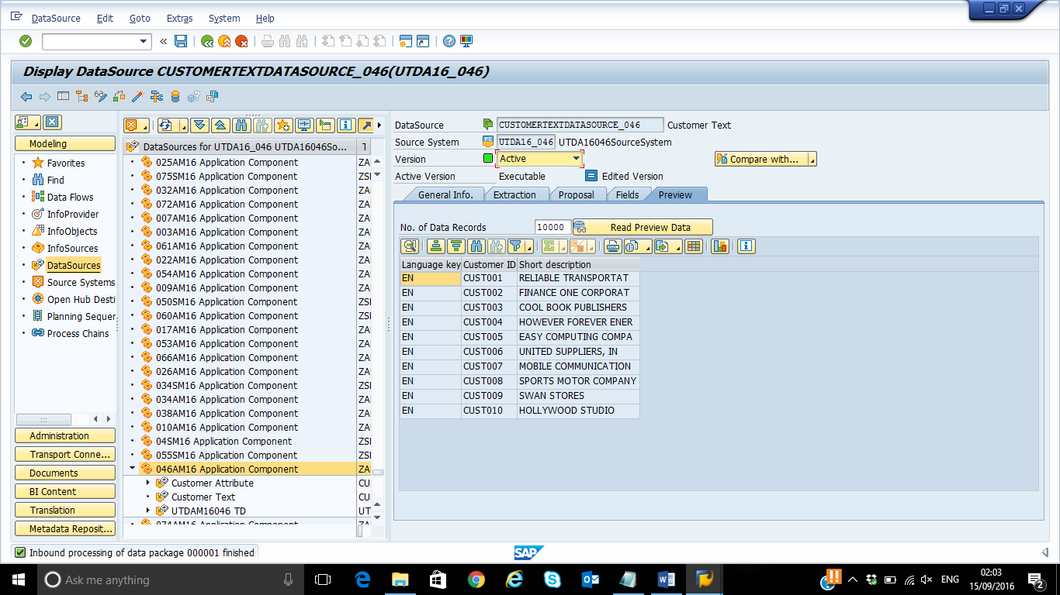

**For Material: MIDSYYXXX, MNMSYYXXX**

**For Sales representative: SRDSYYXXX, SNMSYYXXX**

**5-18: Repeat the above procedure to load Attribute of Material (use the CSV File given) and State how many proposals are generated in the Transformations.**

**Ans: Proposal generated with 2 rule(s)**

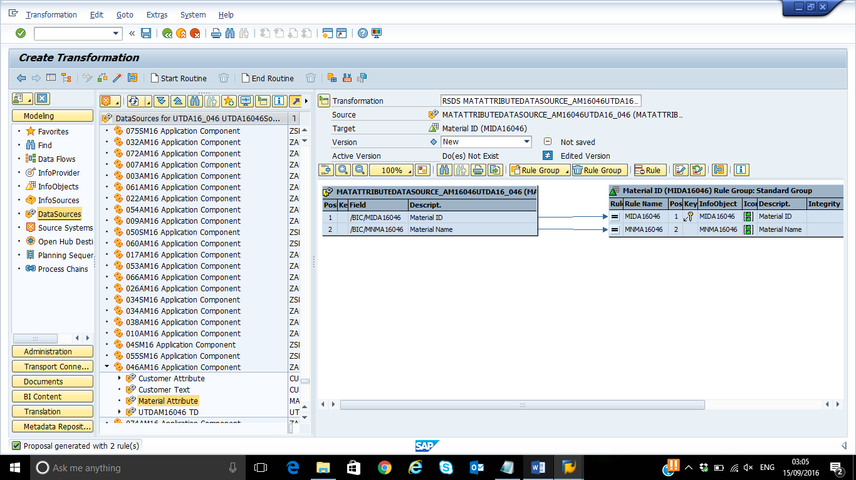

**5-19: Paste the Screenshot of Monitor for Material**

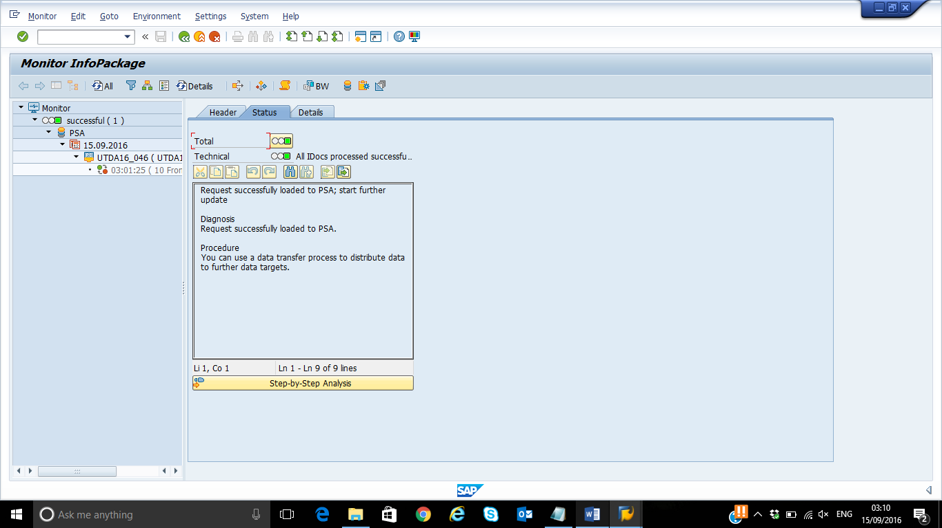

**5-20: Load Text Master Data for Material and paste Screenshot of Read Preview Data.**

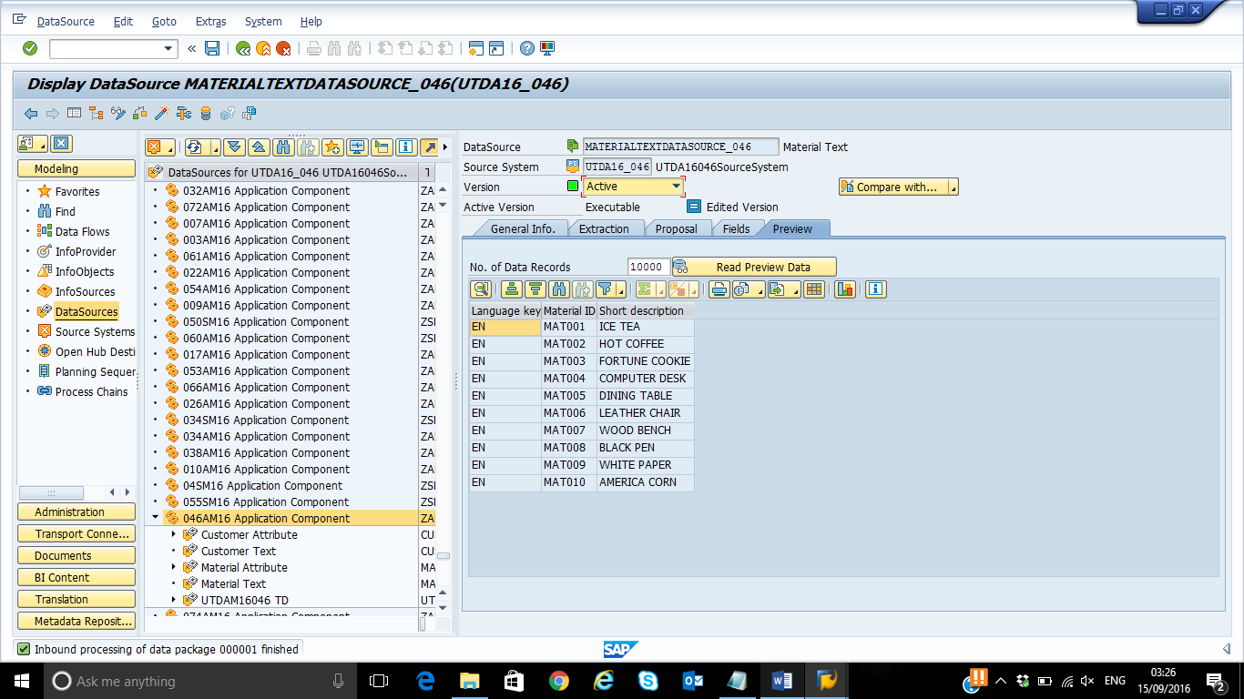

**5-21: Repeat the above procedure to load Attribute of Sales Representative (use the CSV File given) and paste screenshot for Data Source Read Preview Data.**

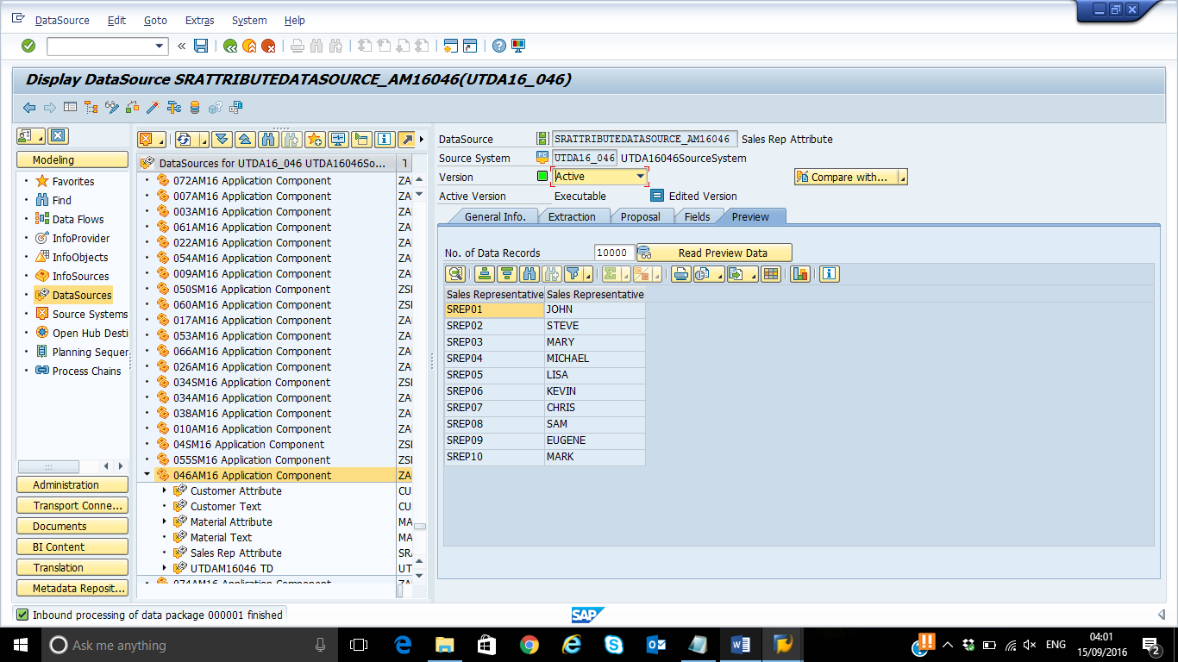

**5-22: Paste screenshot of Data Transfer Execute Step for Sales Representative.**

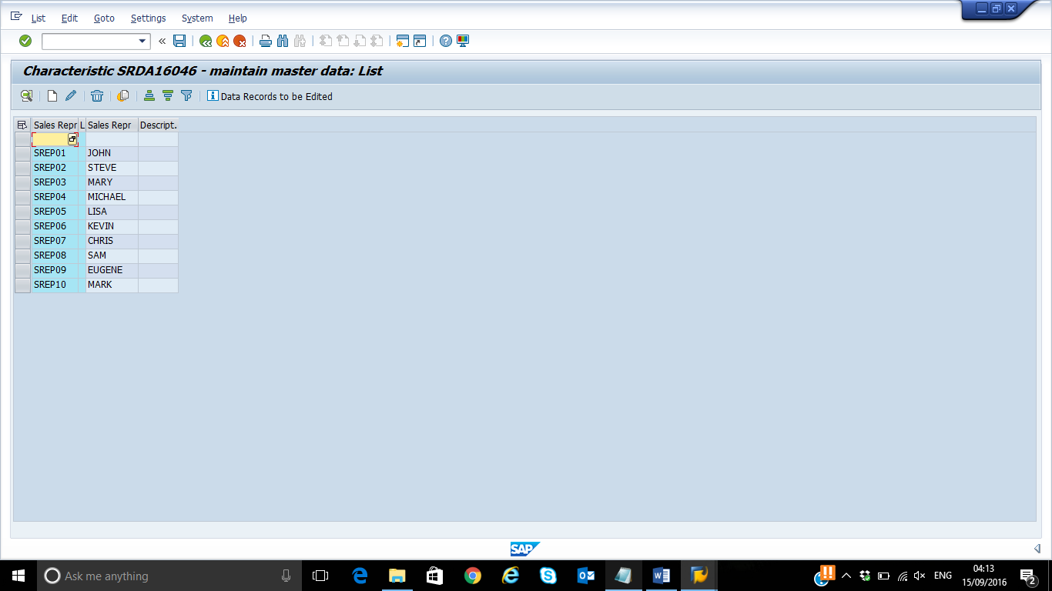

**5-23: Paste Screenshot of Load Example Data for Text Master Data for Sales Representative.**

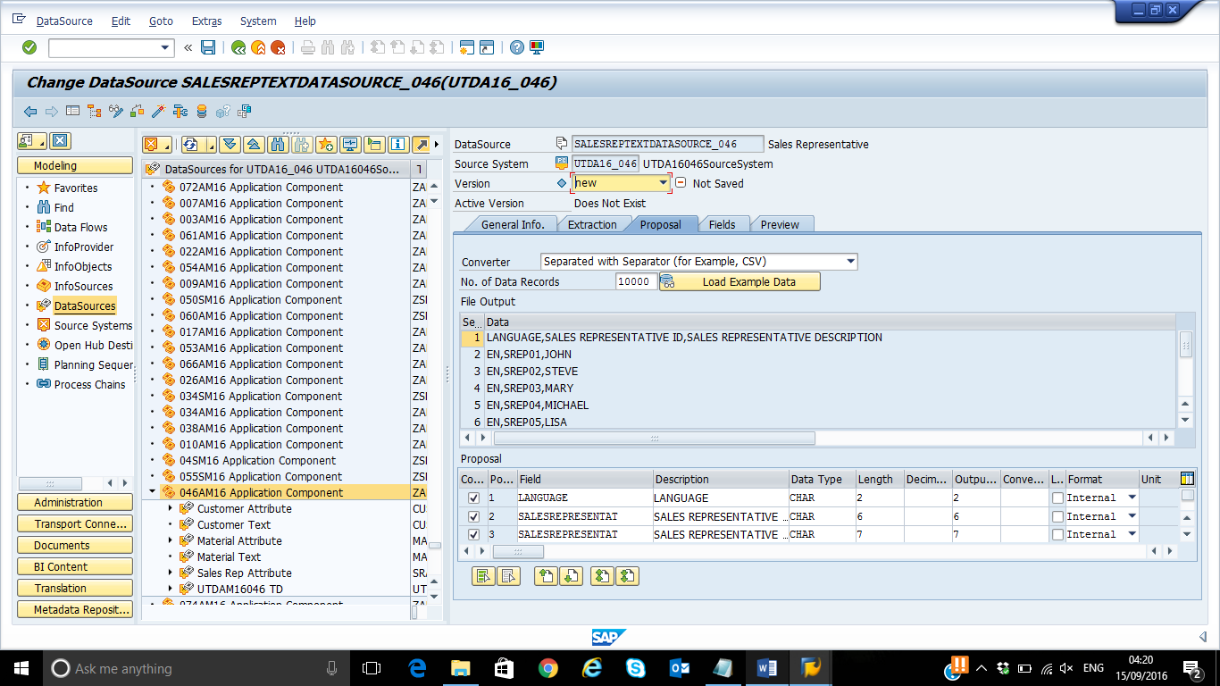

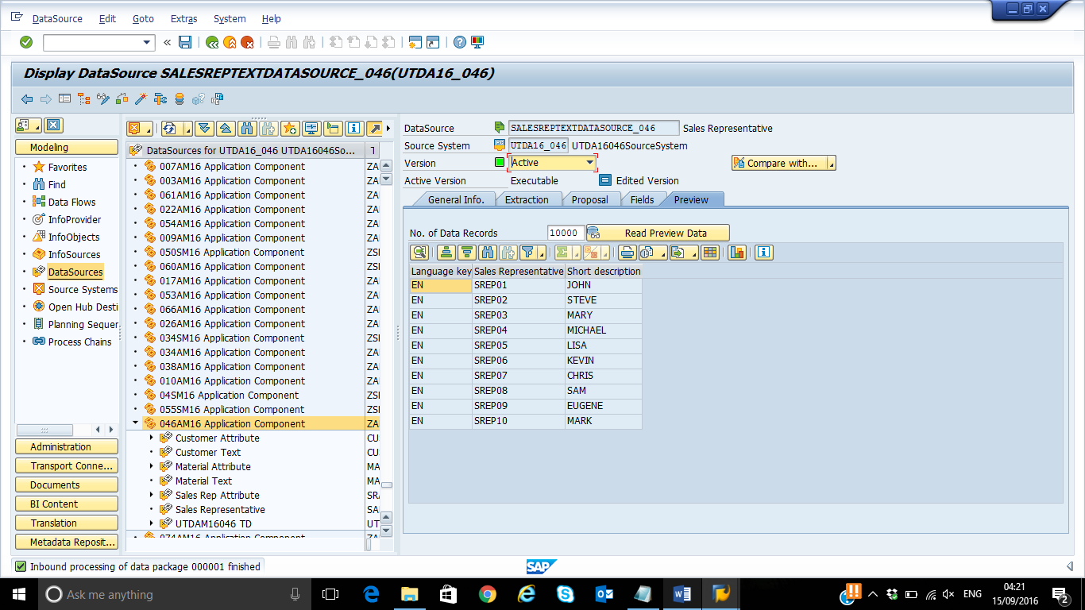

**Step 6: Creating Transformation to load InfoCube**

1. Go to RSA1 and select ‘InfoProvider’ section under Modeling.
2. Right click your InfoCube (**SYYXXX**) and select ‘Create Transformation’.

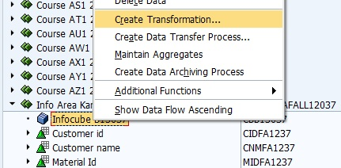

1. Select ‘DataStore Object’ as Object Type and ‘DSSYYXXX’ as Name and hit the green check mark.

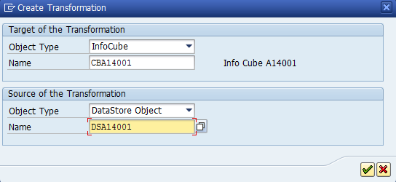

Click on the green check mark.

1. The proposal is automatically generated with rules . Check &Activate the transformation.
2. Right click your InfoCube and create Data Transfer Process. Leave the changes the way they are and hit the green check mark.

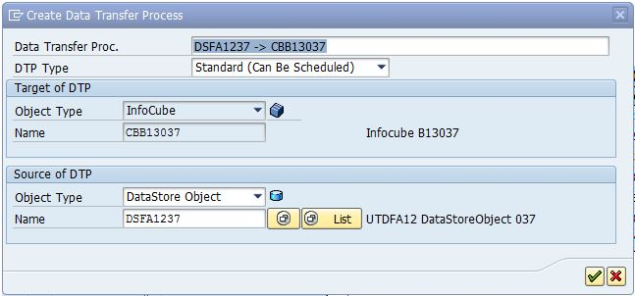

1. Go to ‘Extraction’ tab and make sure you select ‘Full’ extraction mode.
2. Check & Activate the DTP. Go to ‘Execute’ tab and select ‘Execute’. Choose ‘Yes’ to display the monitor.

**Paste your screen shot of the monitor here:**

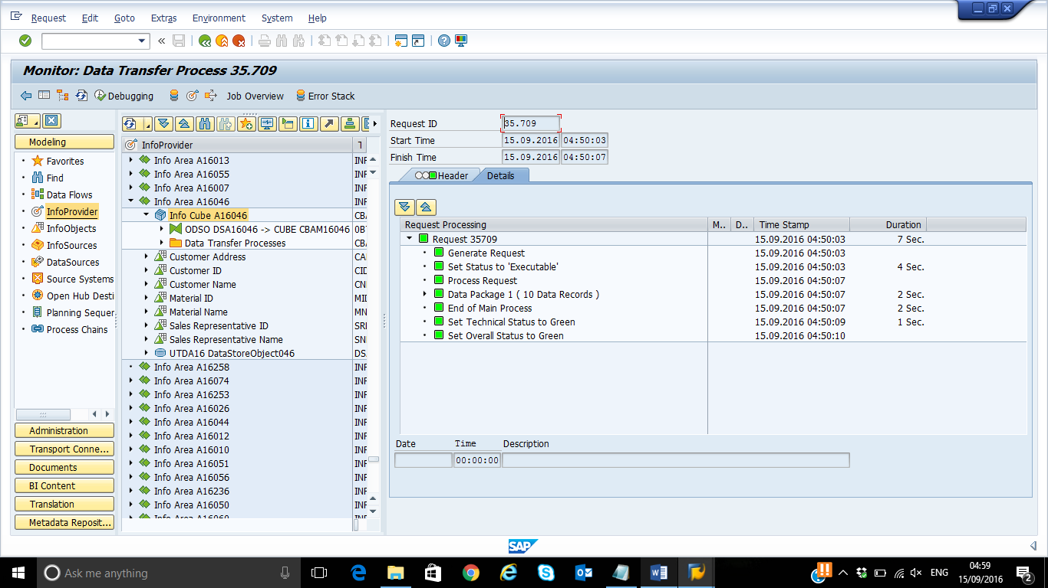

**Step 7: Displaying InfoCube’s Data and Data Flow.**

1. In RSA1 -> InfoProvider locate your InfoCube and right click it. Then select Display Data.
2. Select ‘Fld Selection for Output’ -> ‘Select All’ -> hit ‘Execute’ twice.

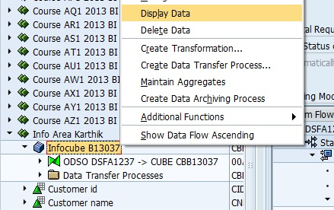

1. **Paste your screen shot with the result.**

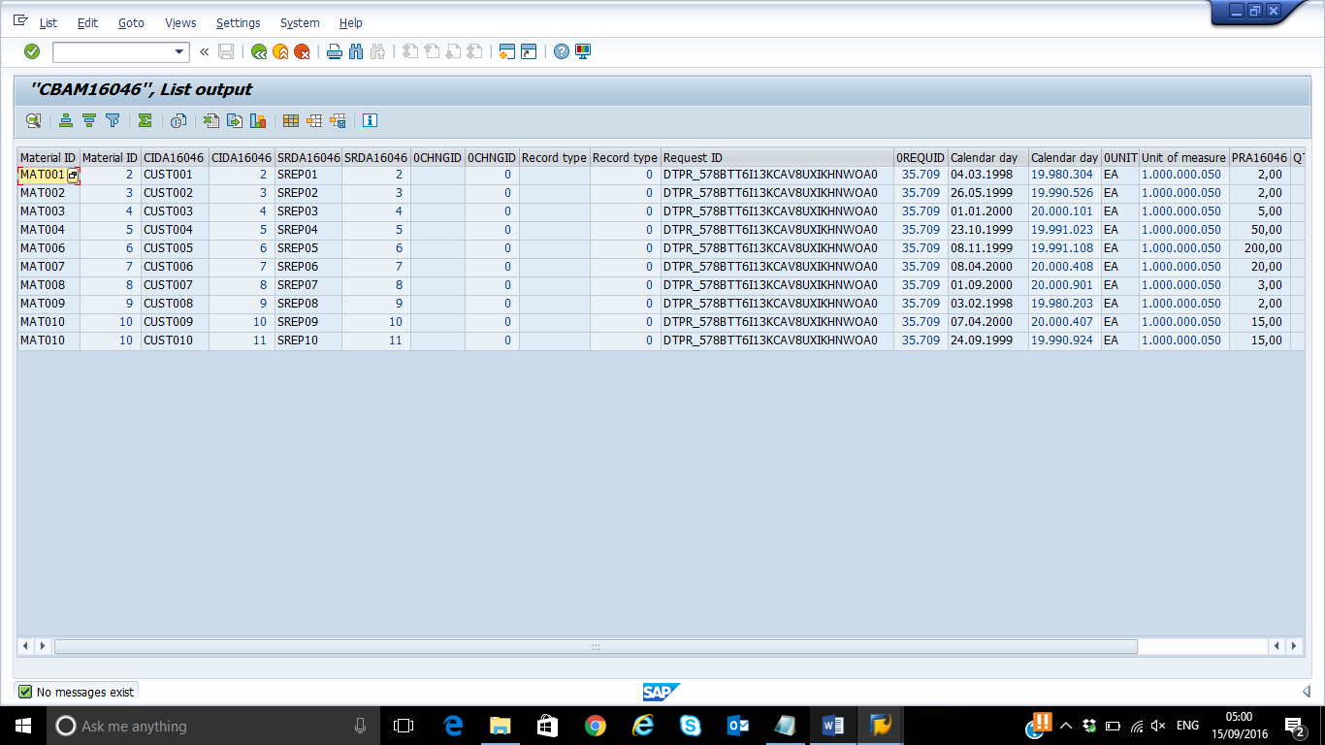

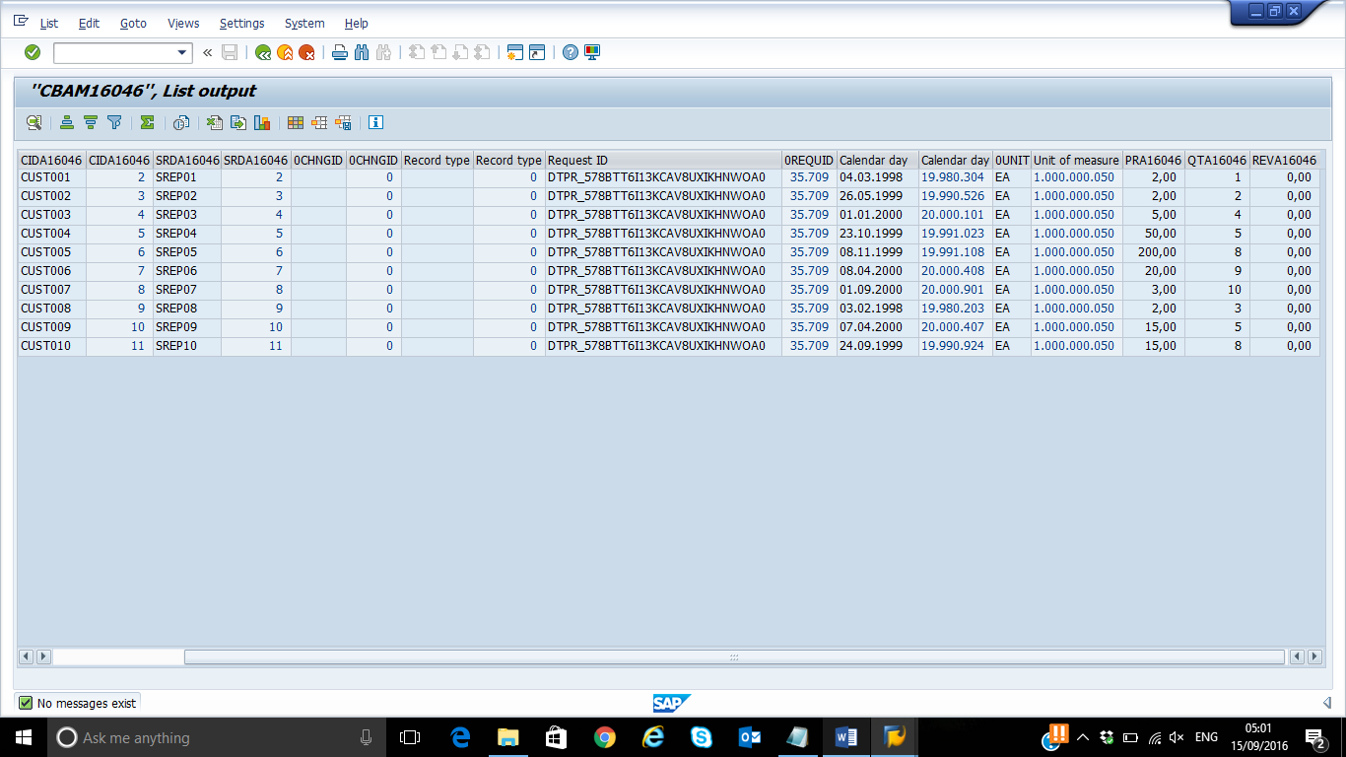

1. Go back to your InfoCube and right click ‘Display Data Flow’. Choose upwards & downwards

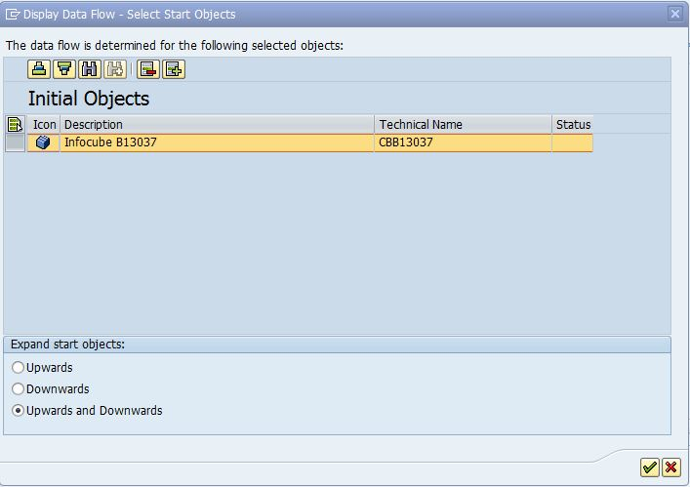

Your screen should look something like this one below (Will not be the same one as below):

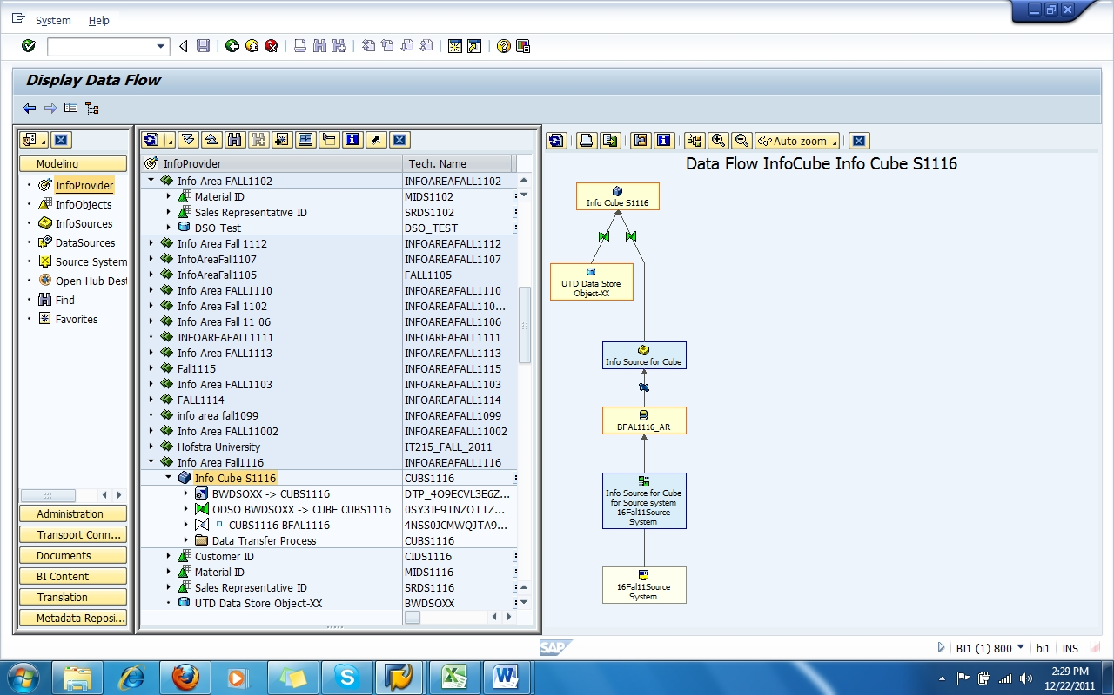

The important point to note is that the data gets loaded from the DSO to the infocube.

The Data Flow display is showing what we have done. We started with the DataStore, then loaded it into DSO and finally we loaded data into our InfoCube. By clicking either one of this objects you will be able to see or modify each of them.

1. **Paste a screen shot of your InfoCube’s data flow here:**

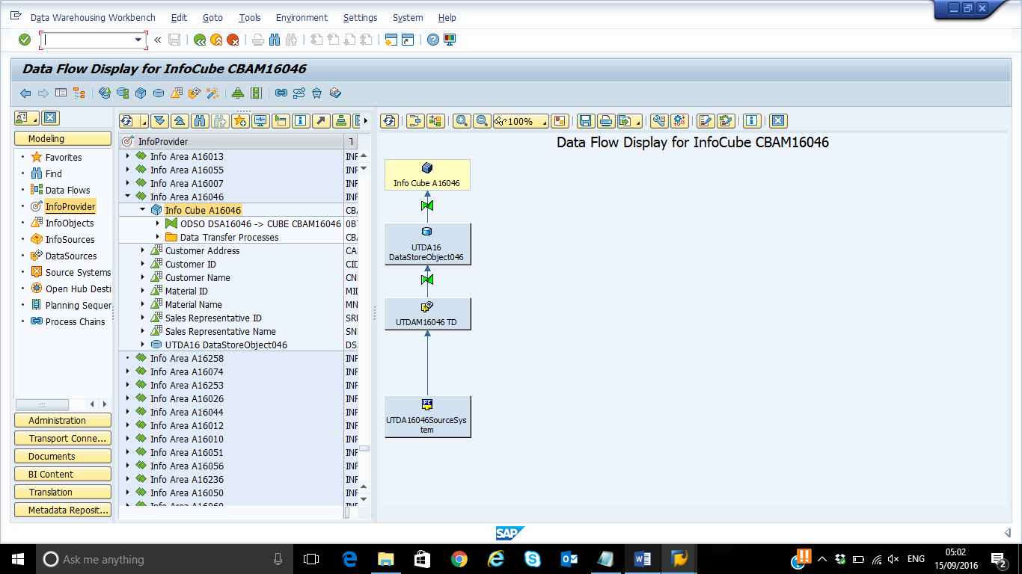

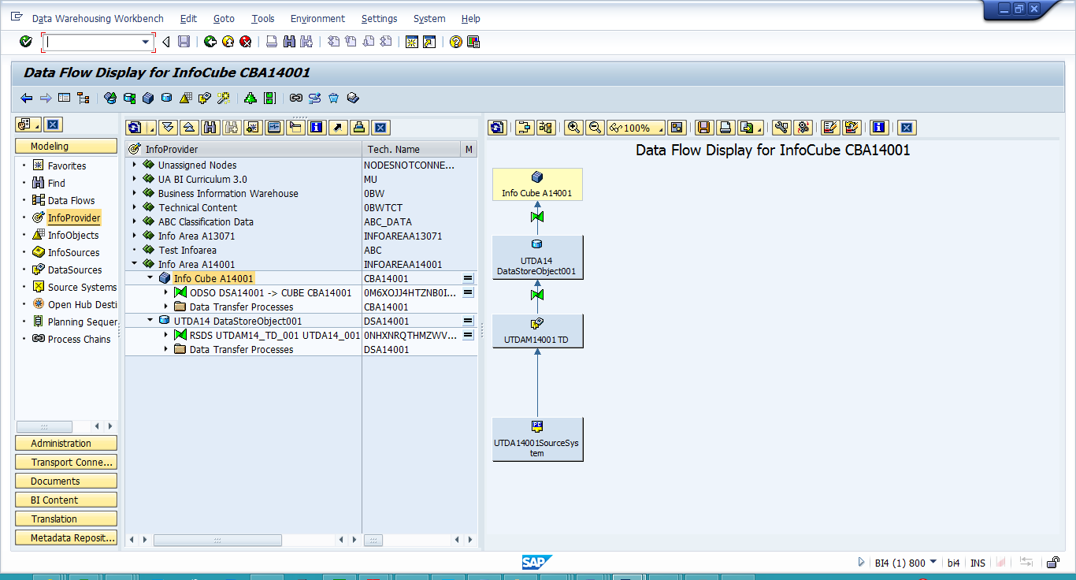

**Step 8: Creating a query against InfoCube.**

* 1. Open your Query Designer and go to Query -> New to create a new query.
  2. Navigate to your Info Area and find your cube

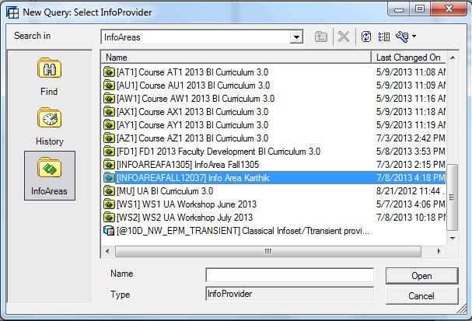 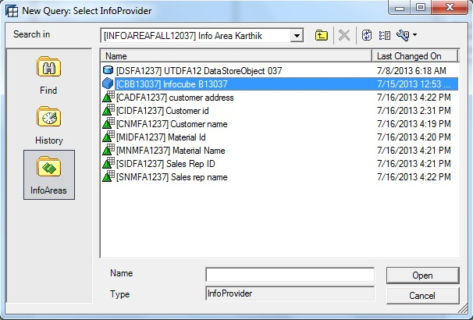

Or Type ‘**CBSYYXXX**’ in find box as shown below where XXX is your ID to find your InfoCube->Enter.

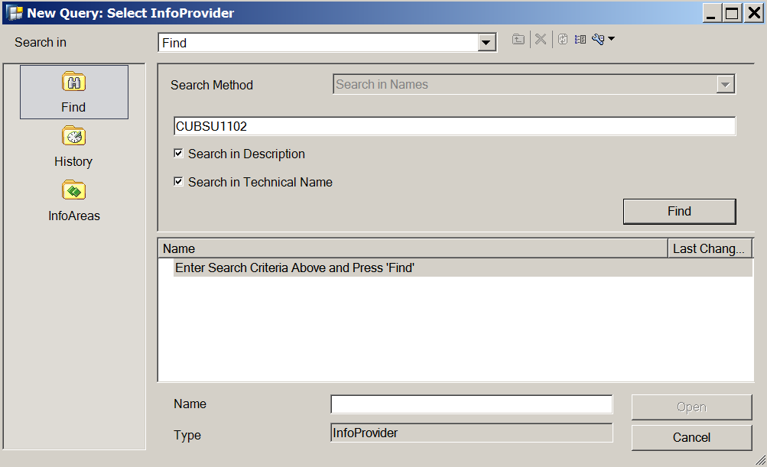

* 1. Double click your InfoCube (or hit Open).
  2. Drag the objects to the proper place as shown below:

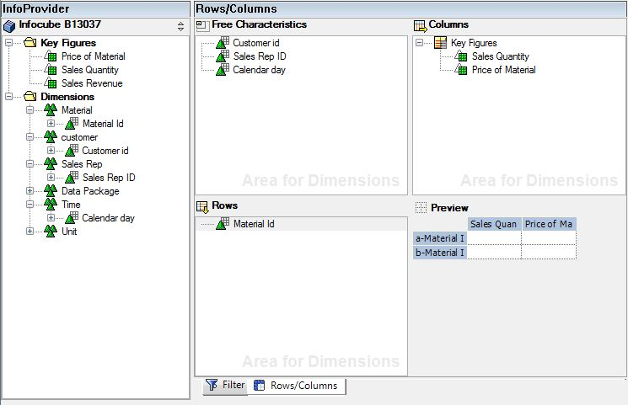

5.Save your query with the tech.name and description: UTDSMYYXXX where XXX is your ID.

6. Run your query using the BEx Analyzer and click on Filter.

Your screen should look like the one below:

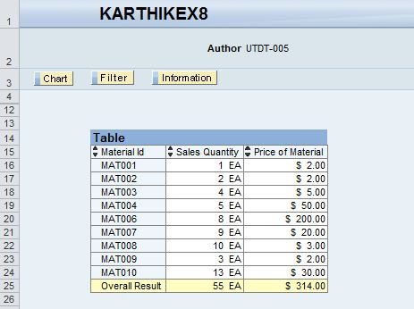

**Paste your screen shot here: (Make sure that ‘Author’ is shown in the screen shot)**

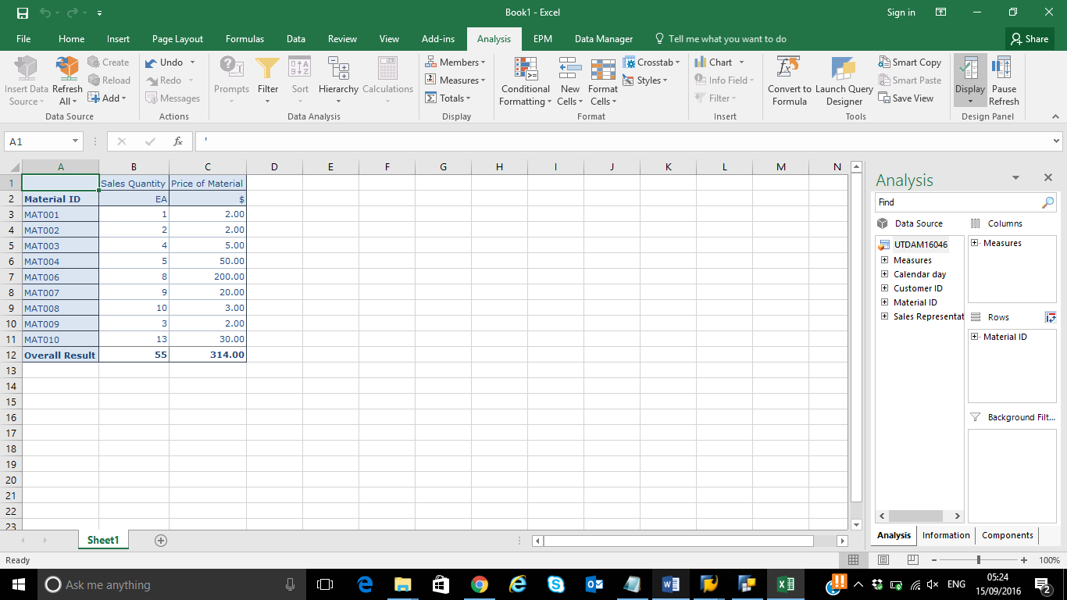

7.**Filter the query by Sales Representative: SREP08 and paste your screen shot of the result here.**

